**ANSIBLE-02**

**PLAYBOOK**

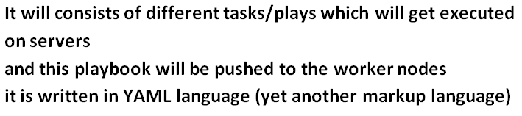

**CREATING A PLAYBOOK FOR INSTALLING APACHE SERVER IN WORKER NODE:**

**And if we are in same VPC then we can configure through “private-key” also,**

**Currently my master node is connected with worker node**

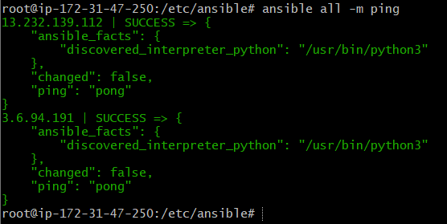

**For creating playbook then we have to mentioned in YAML format**

**And we can check the format by some online validator like:**



**First we will create a YAML file with any name and then we write our play book content like below:**

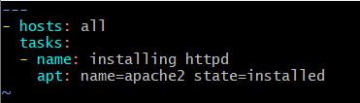

**--- starting of playbook   
- hosts: it will represent groups  
 tasks: it will tell what task we will performed under it  
 - name: it can be any name  
 apt: it an ubuntu-module by which we install our services**

**And then we can check our syntax is valid or not by the help of below command:**



**And if I want to run the playbook we can run with the command “ansible-playbook main.yaml”**

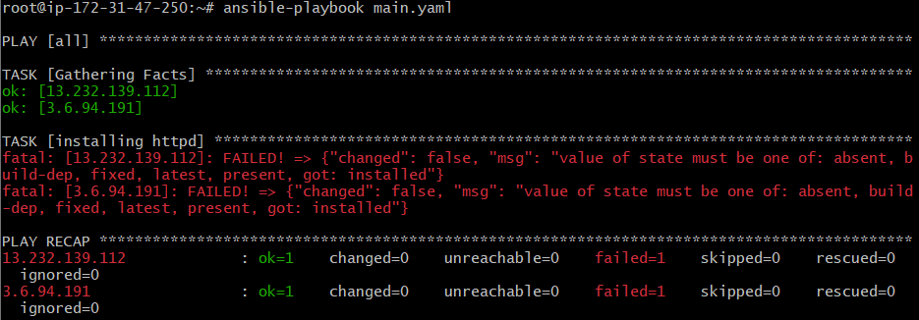

**So we got an error and if we read that error it is saying to use latest state so we will change install to latest in the apt module**

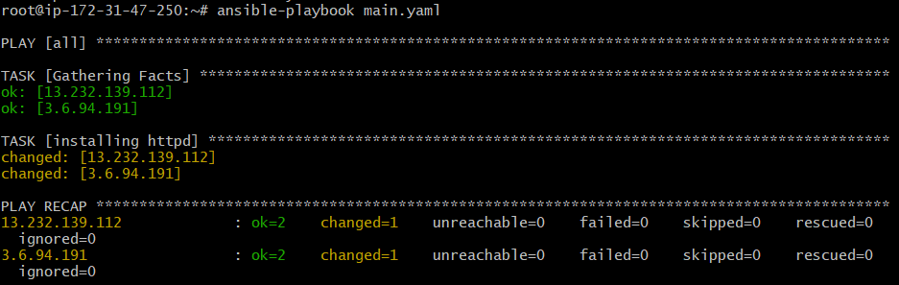

**So now it get installed we can check the status of “changed=1”  
and “ok=1” will represent error in the code and “ok=2” represent all is good**

**Ansible follows the idempotency rule:**

**Idemopotency:**

**Once the file/code exceuted then it won’t execute again and again because the changes has been done so it won’t take it.**

**It will show like below with the code of “ok=2”**

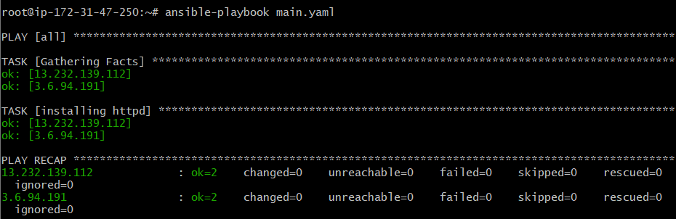

**Now we will check on the worker nodes whether it is installed or not:  
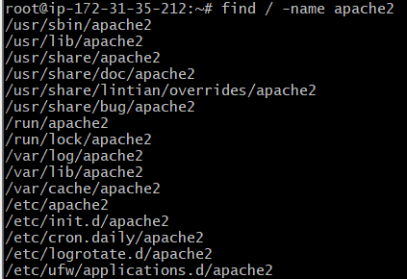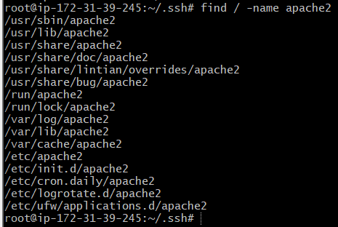**

**But in the master node our apache2 will not be installed because under group all we have mentioned two ip's of worker nodes.  
So playbook is pushed to worker nodes and installed Apache 2If under all you will add master ip also then Apache 2 will be installed on master as well. But that is not recommended and not best practice.**

**And now we will try to delete our web-server which is installed on worker node with the help of playbook:**

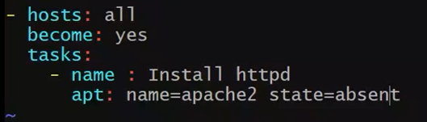

**We have to just mention “state=absent”**

**From the command line also we can pass our module like:-**

**[ansible all –m apt –a “name=httpd state=latest”]**

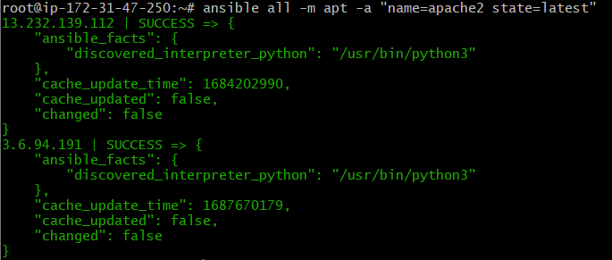

**And if we want to get the complete log we can use the command:**

**“ansible-playbook –vvvv/vvv/vv/v main.yaml ”**

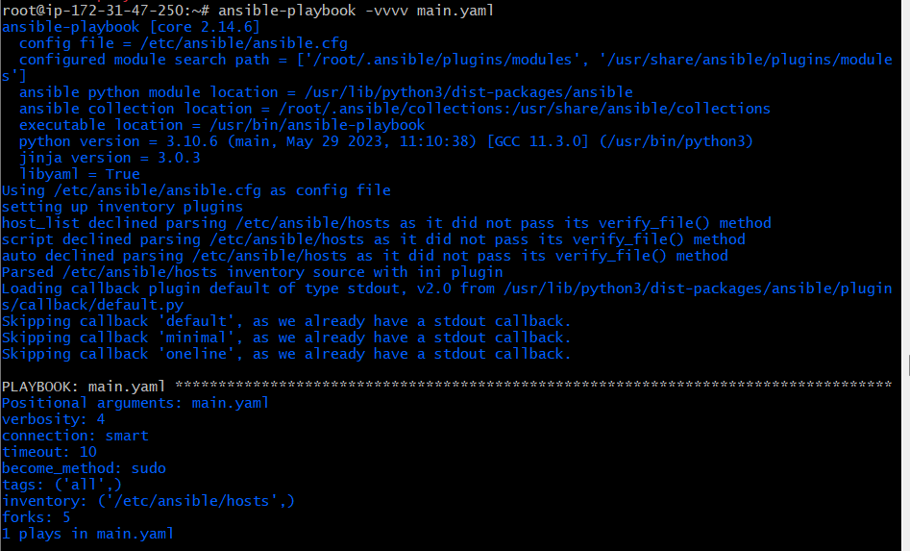

**Then if we want to use multiple task in the playbook the we can write our yaml like below:**

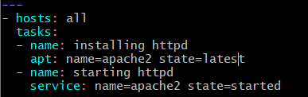

**And then we check the syntax by the below command:**

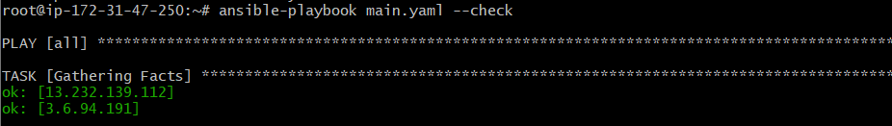

**And then we will run the playbook, after that we can check our worker node whether apache2 is running or not:**

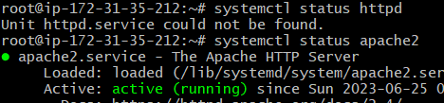

**If we want to check the status of worker node whether our web-server is installed or not in the master node we can use :**

**[ansible all –m shell –a “systemctl status apache2”]**

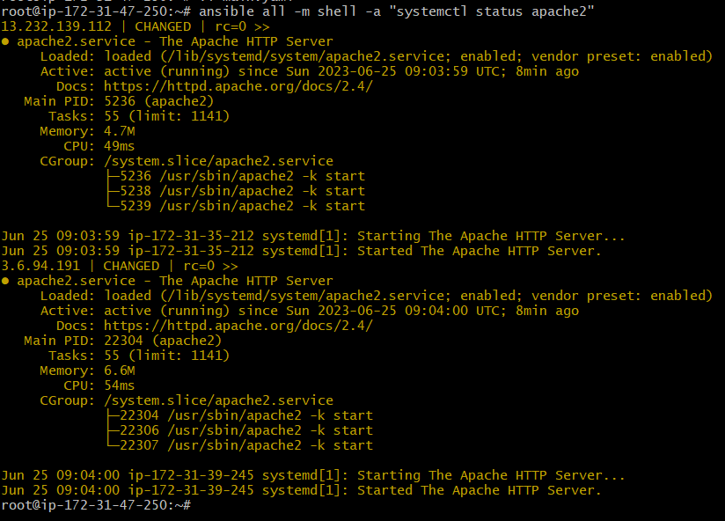

**And if we want to use a file for deploying from inside the master node to the worker node we will use another module name “copy”:**

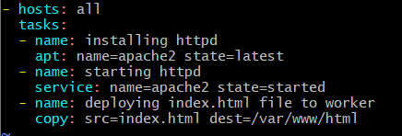

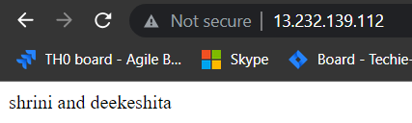

**And if we want to restart our web-server from the help of playbook we will use:**

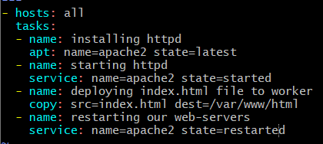

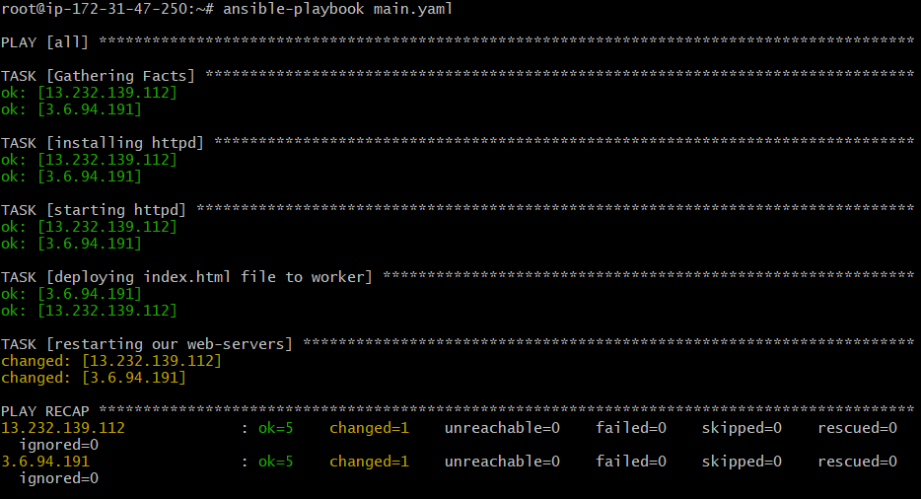

**Here in the status of yaml file we are seeing that 5 task are successfully run by the code of “ok=5”**

**NOTIFY AND HANDLERS (MODULES):**

**Notifier is helps to send the alert to handler   
and handler are used if we have dependency on different plays/task.**

**NOTE: notifier and handler name should be same**

**Example: we are creating a dependency like when task 3 will complete then notify will notifier to next task with the help of handlers**

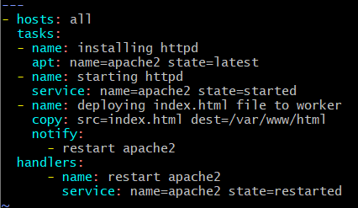

**Register and debug modules:**

**With the help of registry we can save our output and then it can be showcase by using “debug” module to show the output**

